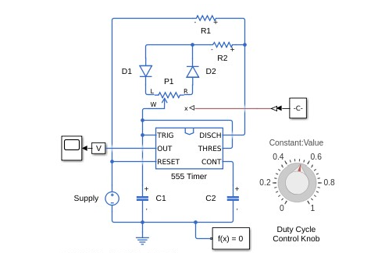
555 Timer Based PWM Generator with Variable Duty Cycle Control

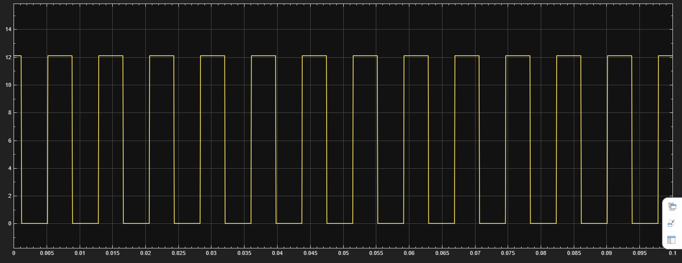
PWM Output Waveform Showing Duty Cycle Variation
- PWM Signal Generation Using 555 Timer IC
- Adjustable Duty Cycle PWM Circuit Using 555 Timer
- 555 Timer Astable PWM Generator
- Pulse Width Modulation Circuit for Motor Speed Control
- Variable PWM Waveform Generator Using NE555

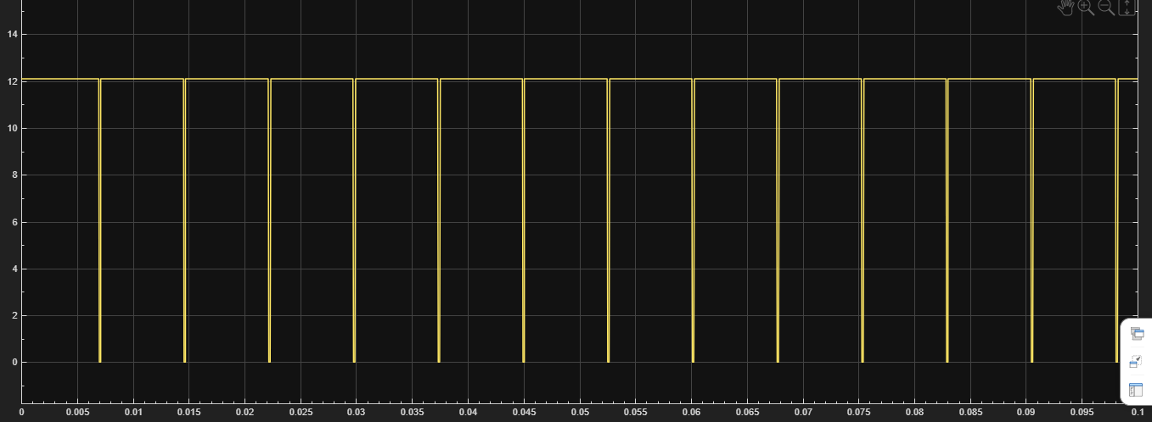

The circuit is supplied with a constant 12 V DC input. By adjusting the potentiometer, the duty cycle of the PWM signal changes. As the duty cycle increases, the average output voltage delivered to the load also increases.

Duty Cycle (%) | Average Output Voltage (V)
20 | 2.4
40 | 4.8
60 | 7.2
80 | 9.6
100 | 12.0

Graph Description
- X-axis: Duty Cycle (%)
- Y-axis: Average Output Voltage (V)
- The graph shows a nearly linear increase in output voltage as the duty cycle increases.
- At 0% duty cycle, the output voltage is approximately 0 V.
- At 100% duty cycle, the output voltage reaches the full supply voltage of 12 V.
- This demonstrates that PWM controls the effective output voltage without changing the supply voltage.

